UNITED STATES
SECURITIES AND EXCHANGE COMMISSION
Washington, D.C. 20549

FORM 8-K

CURRENT REPORT
Pursuant to Section 13 or 15(d) of the
Securities Exchange Act of 1934

Date of Report (Date of earliest event reported): August 6, 2026

Monster Beverage Corporation
(Exact name of registrant as specified in its charter)

Delaware
(State or other jurisdiction of incorporation)

001-18761 |  | 47-1809393
(Commission File Number) |  | (IRS Employer Identification No.)

1 Monster Way
Corona, California 92879
(Address of principal executive offices and zip code)

(951) 739 - 6200
(Registrant’s telephone number, including area code)

N/A
(Former name or former address, if changed since last report)

Check the appropriate box below if the Form 8-K filing is intended to simultaneously satisfy the filing obligation of the registrant under any of the following provisions:

☐ | Written communications pursuant to Rule 425 under the Securities Act (17 CFR 230.425)

☐ | Soliciting material pursuant to Rule 14a-12 under the Exchange Act (17 CFR 240.14a-12)

☐ | Pre-commencement communications pursuant to Rule 14d-2(b) under the Exchange Act (17 CFR 240.14d-2(b))

☐ | Pre-commencement communications pursuant to Rule 13e-4(c) under the Exchange Act (17 CFR 240.13e-4(c))

Securities registered pursuant to Section 12(b) of the Act:

Title of each class |  | Trading Symbol(s) |  | Name of each exchange on which registered
Common Stock |  | MNST |  | Nasdaq Global Select Market

Indicate by check mark whether the registrant is an emerging growth company as defined in Rule 405 of the Securities Act of 1933 (17 CFR §230.405) or Rule 12b-2 of the Securities Exchange Act of 1934 (17 CFR §240.12b-2).

Emerging growth company ☐

If an emerging growth company, indicate by check mark if the registrant has elected not to use the extended transition period for complying with any new or revised financial accounting standards provided pursuant to Section 13(a) of the Exchange Act. ☐

Item 2.02. Results of Operations and Financial Condition.

On August 6, 2026, Monster Beverage Corporation (the “Company”) issued a press release relating to its financial results for the second quarter ended June 30, 2026, a copy of which is furnished as Exhibit 99.1 hereto. The press release did not include certain financial statements, related footnotes and certain other financial information that will be filed with the Securities and Exchange Commission as part of the Company’s Quarterly Report on Form 10-Q.

On August 6, 2026, the Company will conduct a conference call at 2:00 p.m. Pacific Time. The conference call will be open to all interested investors through a live audio web broadcast via the internet at www.monsterbevcorp.com in the “Events & Presentations” section. For those who are not able to listen to the live broadcast, the call will be archived for approximately one year on the website.

Item 7.01. Regulation FD Disclosure.

The Company’s investor presentation containing scanner data for the second quarter ended June 30, 2026 is furnished as Exhibit 99.2 to this Current Report on Form 8-K.

The information under Items 2.02 and 7.01 above (including Exhibits 99.1 and 99.2 hereto) is being furnished and shall not be deemed “filed” for purposes of Section 18 of the Securities Exchange Act of 1934, as amended, or otherwise subject to the liabilities of that section, nor shall it be deemed incorporated by reference in any filing under the Securities Act of 1933, as amended, except as expressly set forth by specific reference in such filing.

Item 9.01. Financial Statements and Exhibits.

(d) Exhibits

Exhibit 99.1 | Press Release dated August 6, 2026.
Exhibit 99.2 | Investor Presentation.
Exhibit 104 | The cover page from this Current Report on Form 8-K, formatted in iXBRL (Inline eXtensible Business Reporting Language).

SIGNATURES

Pursuant to the requirements of the Securities Exchange Act of 1934, the registrant has duly caused this report to be signed on its behalf by the undersigned hereunto duly authorized.

 | Monster Beverage Corporation
Date: August 6, 2026 | /s/ Hilton H. Schlosberg
 | Hilton H. Schlosberg
 | Vice Chairman of the Board of Directors and
 | Chief Executive Officer

Exhibit 99.1

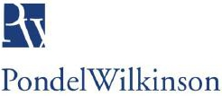

Investor Relations  Strategic Public Relations | PondelWilkinson Inc.  2945 Townsgate Road, Suite 200  Westlake Village, CA 91361  T (310) 279 5980  W www.pondel.com

CONTACTS:  NEWS  RELEASE | Mark Astrachan  SVP, Investor Relations & Corporate Development  (951) 739-6200  Roger S. Pondel / Judy Lin  PondelWilkinson Inc.  (310) 279-5980

MONSTER BEVERAGE REPORTS 2026 SECOND QUARTER FINANCIAL RESULTS

2026 Second Quarter Highlights

 | • | Net Sales rise 20.2 percent to $2.54 billion

 | • | Net Income increases 19.6 percent to $584.5 million (15.7 percent to $590.5 million on a non-GAAP adjusted basis)1

 | • | Net Income Per Diluted Share increases 19.0 percent to $0.59 per share (15.2 percent to $0.60 per share on a non-GAAP adjusted basis)

1The tables at the end of this press release provide a reconciliation of non-GAAP financial measures to the Company’s results, as reported under GAAP. (See “Reconciliation of GAAP and Non-GAAP Information” below).

Corona, CA – August 6, 2026 – Monster Beverage Corporation (NASDAQ: MNST) today reported financial results for the three- and six-months ended June 30, 2026.

Net sales for the 2026 second quarter increased 20.2 percent to $2.54 billion, from $2.11 billion in the same period last year. Net changes in foreign currency exchange rates had a favorable impact on net sales for the 2026 second quarter of $48.5 million. Net sales on a foreign currency adjusted basis (non-GAAP) increased 17.9 percent in the 2026 second quarter.

Net sales, excluding the Alcohol Brands segment (non-GAAP), increased 20.8 percent in the 2026 second quarter. Net sales, excluding the Alcohol Brands segment, on a foreign currency adjusted basis (non-GAAP), increased 18.5 percent in the 2026 second quarter.

Net sales for the Company’s Monster Energy® Drinks segment, which primarily includes the Company’s Monster Energy® drinks, Reign Total Body Fuel® high performance energy drinks, Bang Energy® drinks, StormTM and Reign Storm® total wellness energy drinks and FLRTTM total wellness energy drinks, increased 21.6 percent to $2.36 billion for the 2026 second quarter, from $1.94 billion for the 2025 second quarter. Net changes in foreign currency exchange rates had a favorable impact on net sales for the Monster Energy® Drinks segment of approximately $45.3 million for the 2026 second quarter. Net sales on a foreign currency adjusted basis (non-GAAP) for the Monster Energy® Drinks segment increased 19.3 percent in the 2026 second quarter.

(more)

Monster Beverage Corporation
2-2-2

Net sales for the Company’s Strategic Brands segment, which primarily includes the various energy drink brands acquired from The Coca-Cola Company, as well as the Company’s affordable energy brands, Predator® and Fury®, increased 10.6 percent to $143.7 million for the 2026 second quarter, from $129.9 million in the 2025 second quarter. Net changes in foreign currency exchange rates had a favorable impact on net sales for the Strategic Brands segment of approximately $3.3 million for the 2026 second quarter. Net sales on a foreign currency adjusted basis (non-GAAP) for the Strategic Brands segment increased 8.1 percent in the 2026 second quarter.

Net sales for the Alcohol Brands segment, which is comprised of various craft beers, flavored malt beverages and hard seltzers, decreased 15.2 percent to $32.2 million for the 2026 second quarter, from $38.0 million in the 2025 second quarter.

Net sales for the Company’s Other segment, which primarily includes certain products of American Fruits and Flavors, LLC, a wholly owned subsidiary of the Company, sold to independent third-party customers, decreased 15.3 percent to $5.4 million for the 2026 second quarter, from $6.4 million in the 2025 second quarter.

Net sales to customers outside the United States increased 34.6 percent to $1.16 billion in the 2026 second quarter, from $864.2 million in the 2025 second quarter, representing approximately 46 percent and 41 percent of total reported net sales for the 2026 and 2025 second quarters, respectively. Net sales to customers outside the United States, on a foreign currency adjusted basis (non-GAAP), increased 29.0 percent to $1.11 billion in the 2026 second quarter.

Gross profit as a percentage of net sales for the 2026 second quarter was 55.9 percent, compared with 55.7 percent in the 2025 second quarter. The increase in gross profit as a percentage of net sales for the 2026 second quarter was primarily the result of pricing actions and product sales mix, partially offset by increased aluminum can costs, geographical sales mix and increased freight-in costs. Adjusted gross profit (non-GAAP) as a percentage of net sales, excluding the Alcohol Brands segment, for the 2026 second quarter was 56.3 percent, compared with 56.2 percent in the 2025 second quarter.

Distribution expenses for the 2026 second quarter were $118.8 million, or 4.7 percent of net sales, compared with $82.0 million, or 3.9 percent of net sales, in the 2025 second quarter.

Selling expenses for the 2026 second quarter were $269.2 million, or 10.6 percent of net sales, compared with $196.9 million, or 9.3 percent of net sales, in the 2025 second quarter. The increase in selling expenses for the 2026 second quarter was primarily due to increased social, digital, media and other marketing expenses, including sponsorships and endorsements, in order to reach a broader consumer audience and increase household penetration.

General and administrative expenses for the 2026 second quarter were $291.2 million, or 11.5 percent of net sales, compared with $265.9 million, or 12.6 percent of net sales, for the 2025 second quarter. Stock-based compensation was $35.7 million for the 2026 second quarter, compared with $33.2 million in the 2025 second quarter.

Operating expenses for the 2026 second quarter were $679.2 million, compared with $544.8 million in the 2025 second quarter. Adjusted operating expenses (non-GAAP) for the 2026 second quarter were $662.7 million, compared with $505.6 million in the 2025 second quarter. Operating expenses as a percentage of net sales for the 2026 second quarter were 26.8 percent, compared with 25.8 percent in the 2025 second quarter. Adjusted operating expenses (non-GAAP) as a percentage of net sales, less the Alcohol Brands segment, were 26.5 percent and 24.4 percent for the 2026 and 2025 second quarters, respectively.

(more)

Monster Beverage Corporation
3-3-3

Operating income for the 2026 second quarter increased 17.2 percent to $740.4 million, from $631.6 million in the 2025 second quarter. Adjusted operating income (non-GAAP) for the 2026 second quarter increased 13.3 percent to $748.1 million, from $660.1 million in the 2025 second quarter.

The effective tax rate for the 2026 second quarter was 23.9 percent, compared with 24.4 percent in the 2025 second quarter.

Net income for the 2026 second quarter increased 19.6 percent to $584.5 million, from $488.8 million in the 2025 second quarter. Adjusted net income (non-GAAP) for the 2026 second quarter increased 15.7 percent to $590.5 million, from $510.4 million in the 2025 second quarter. Net income per diluted share for the 2026 second quarter increased 19.0 percent to $0.59, from $0.50 in the 2025 second quarter. Adjusted net income per diluted share (non-GAAP) for the 2026 second quarter increased 15.2 percent to $0.60, from $0.52 in the second quarter of 2025.

Hilton H. Schlosberg, Chief Executive Officer, said, “We delivered a strong 2026 second quarter, with net sales increasing 20.2 percent and net income per diluted share increasing 19.0 percent.

“Our international operations continued their meaningful contribution to revenue growth, with net sales to customers outside the United States increasing 34.6 percent in the 2026 second quarter to approximately 46 percent of total net sales.

“The energy drink category continues to attract new consumers, expand usage occasions and increase household penetration. Our 2026 marketing strategy includes increased marketing investments across a variety of new platforms and partnerships, including social, digital and media, to support both existing product offerings and new product launches, as well as reach a broadening consumer base for the Company.

“We remain focused on the growth of our existing core offerings as well as the continued introduction of product innovations, which remain central to our long-term growth strategy,” Mr. Schlosberg added.

2026 Six-Months Results

Net sales for the six-months ended June 30, 2026 increased 23.3 percent to $4.89 billion, from $3.97 billion in the comparable period last year. Net changes in foreign currency exchange rates had a favorable impact of $137.8 million on net sales for the six-months ended June 30, 2026. Net sales on a foreign currency adjusted basis (non-GAAP) increased 19.8 percent in the six-months ended June 30, 2026. Net sales, excluding the Alcohol Brands segment, on a foreign currency adjusted basis (non-GAAP), increased 20.4 percent in the six-months ended June 30, 2026.

Gross profit as a percentage of net sales for the six-months ended June 30, 2026 was 55.5 percent, compared with 56.1 percent in the comparable period last year.

Operating expenses for the six-months ended June 30, 2026 were $1.24 billion, compared with $1.02 billion in the comparable period last year.

Operating income for the six-months ended June 30, 2026 increased to $1.47 billion, from $1.20 billion in the comparable period last year.

The effective tax rate for the six-months ended June 30, 2026 was 24.0 percent, compared with 23.9 percent in the comparable period last year.

Net income for the six-months ended June 30, 2026 increased 23.9 percent to $1.15 billion, from $931.8 million in the comparable period last year. Net income per diluted share for the six-months ended June 30, 2026 was $1.17, compared with $0.95 in the comparable period last year.

(more)

Monster Beverage Corporation
4-4-4

Share Repurchase Program

During the 2026 second quarter, no shares of the Company’s common stock were repurchased. As of August 5, 2026, approximately $900.0 million remained available for repurchase under the previously authorized repurchase programs.

Stock Split

As previously announced, the Company’s Board of Directors approved and declared a two-for-one stock split of its common stock to be effected in the form of a 100% stock dividend. The stock dividend will be distributed after close of trading on August 10, 2026. The Company anticipates its common stock to begin trading at the split-adjusted price on August 11, 2026.

Investor Conference Call

The Company will host an investor conference call today, August 6, 2026, at 2:00 p.m. Pacific Time (5:00 p.m. Eastern Time). The conference call will be open to all interested investors through a live audio web broadcast via the internet at www.monsterbevcorp.com in the “Events & Presentations” section. For those who are not able to listen to the live broadcast, the call will be archived for approximately one year on the website.

Monster Beverage Corporation

Based in Corona, California, Monster Beverage Corporation is a holding company and conducts no operating business except through its consolidated subsidiaries. The Company’s subsidiaries develop and market energy drinks, including Monster Energy® drinks, Monster Energy Ultra® energy drinks, Juice Monster® and Punch Monster® Energy + Juice energy drinks, Java Monster® and Monster Killer Brew® non-carbonated coffee + energy drinks, Rehab® Monster® non-carbonated energy drinks, Monster Energy® Nitro energy drinks, Reign Total Body Fuel® high performance energy drinks, StormTM and Reign Storm® total wellness energy drinks, NOS® energy drinks, Full Throttle® energy drinks, Bang Energy® drinks, FLRT™ total wellness energy drinks, BPM® energy drinks, BU® energy drinks, Burn® energy drinks, Live+® energy drinks, Mother® energy drinks, Nalu® energy drinks, Play® and Power Play® (stylized) energy drinks, Relentless® energy drinks, Samurai® energy drinks, Ultra Energy® drinks, Predator® energy drinks and Fury® energy drinks. The Company’s subsidiaries also develop and market craft beers, flavored malt beverages and hard seltzers under a number of brands, including Jai Alai® IPA, Dale’s Pale Ale®, Dallas Blonde®, Wild Basin® hard seltzers, The BeastTM, Blind Lemon® and Blinder Lemon™. For more information visit www.monsterbevcorp.com.

(more)

Monster Beverage Corporation
5-5-5

Caution Concerning Forward-Looking Statements

Certain statements made in this announcement may constitute “forward-looking statements” within the meaning of the U.S. federal securities laws, as amended, regarding the expectations of management with respect to our future operating results and other future events including revenues and profitability. The Company cautions that these statements are based on management’s current knowledge and expectations and are subject to certain risks and uncertainties, many of which are outside of the control of the Company, that could cause actual results and events to differ materially from the statements made herein. Such risks and uncertainties include, but are not limited to, the following: the timing and completion of the stock split; our ability to sustain and/or surpass the current level of sales of our products, to adapt to changing consumer preferences, and to effectively respond to competitive products and pricing pressures; our ability to implement our growth strategy, including expanding our business in existing and new sectors and achieving profitability within our Alcohol Brands segment; our ability to adapt to the changing retail landscape with the rapid growth in e-commerce retailers and e-commerce websites; our ability to absorb, reduce or pass on to our bottlers/distributors increases in costs and expenses, including, but not limited to, increases to the cost of aluminum and other raw materials, the Midwest Premium, and freight costs; the impact of the current U.S. presidential administration’s policies on our energy drinks due to concerns about sugar-sweetened beverages, particular ingredients, such as food dyes, and the “generally recognized as safe” (GRAS) process; the impact of proposed or adopted domestic and/or foreign legislation to limit or restrict the sale of energy drinks (including the prohibition of the sale of energy drinks to certain demographics, at certain establishments, in certain container sizes or pursuant to certain governmental programs, such as the Supplemental Nutrition Assistance Program (SNAP)); the impact of changes in U.S. trade policies, including the imposition of additional tariffs; the impact of adverse changes in our costs, supply chain, inflation or consumer demand for our products; the imposition of new and/or increased excise sales and/or other taxes on our products; our extensive commercial arrangements with The Coca-Cola Company (TCCC) and, as a result, our future performance’s substantial dependence on the success of our relationship with TCCC; the effects of unilateral decisions by bottlers/distributors and/or retailers on our business, including their distribution and placement of our products, their consolidation, their discontinuation, or restriction of the range of, all or any of our products that they carry, their limitations on the sale or sizes of our products, and/or their allocation of less resources to the sale of our products; changes in the price and/or availability of raw materials and other supply chain issues, such as the availability of products, suitable production facilities and/or co-packing arrangements; possible recalls of our products and/or the consequences and costs of defective production; disruption to our manufacturing facilities and operations related to climate, labor, production difficulties, capacity limitations, regulations or other causes; disruption to and/or lack of effectiveness of our information technology systems, including internal and external cybersecurity threats and breaches; adverse publicity surrounding obesity, alcohol consumption and other health concerns related to our products, product safety and quality; liabilities resulting from legal or regulatory proceedings, government investigations, and/or injunctions; the inherent operational risks, including the abuse or misuse of our products presented by the alcoholic beverage industry and/or related claims that may not be adequately covered by insurance or may lead to litigation; the current uncertainty and volatility in the national and global economy and changes in demand due to such economic conditions, including a slowdown in consumer spending generally; and the impact of military and geopolitical conflicts, including supply chain disruptions, volatility in commodity prices, increased economic uncertainty and escalating geopolitical tensions. For a more detailed discussion of these and other risks that could affect our operating results, see the Company’s reports filed with the Securities and Exchange Commission, including our annual report on Form 10-K for the year ended December 31, 2025 and our subsequently filed quarterly report. The Company’s actual results could differ materially from those contained in the forward-looking statements. The Company assumes no obligation to update any forward-looking statements, whether as a result of new information, future events or otherwise.

# # #

(tables below)

MONSTER BEVERAGE CORPORATION AND SUBSIDIARIES
CONDENSED CONSOLIDATED STATEMENTS OF INCOME AND OTHER INFORMATION
FOR THE THREE- AND SIX-MONTHS ENDED JUNE 30, 2026 AND 2025
(In Thousands, Except Per Share Amounts) (Unaudited)

 |  | Three-Months Ended |  |  |  |  |  |  |  | Six-Months Ended
 |  | June 30, |  |  |  |  |  |  |  | June 30,
 |  | 2026 |  |  |  | 2025 |  |  |  | 2026 |  |  |  | 2025
Net sales1 |  | $ | 2,537,473 |  |  | $ | 2,111,593 |  |  | $ | 4,890,764 |  |  | $ | 3,966,150
Cost of sales |  |  | 1,117,839 |  |  |  | 935,180 |  |  |  | 2,177,781 |  |  |  | 1,741,775
Gross profit1 |  |  | 1,419,634 |  |  |  | 1,176,413 |  |  |  | 2,712,983 |  |  |  | 2,224,375
Gross profit as a percentage of net sales |  |  | 55.9 | % |  |  | 55.7 | % |  |  | 55.5 | % |  |  | 56.1 | %
Operating expenses |  |  | 679,192 |  |  |  | 544,791 |  |  |  | 1,242,582 |  |  |  | 1,023,008
Operating expenses as a percentage of net sales |  |  | 26.8 | % |  |  | 25.8 | % |  |  | 25.4 | % |  |  | 25.8 | %
Operating income1 |  |  | 740,442 |  |  |  | 631,622 |  |  |  | 1,470,401 |  |  |  | 1,201,367
Operating income as a percentage of net sales |  |  | 29.2 | % |  |  | 29.9 | % |  |  | 30.1 | % |  |  | 30.3 | %
Interest and other income, net |  |  | 27,827 |  |  |  | 15,065 |  |  |  | 47,997 |  |  |  | 23,337
Income before provision for income taxes1 |  |  | 768,269 |  |  |  | 646,687 |  |  |  | 1,518,398 |  |  |  | 1,224,704
Provision for income taxes |  |  | 183,729 |  |  |  | 157,893 |  |  |  | 364,373 |  |  |  | 292,917
Income taxes as a percentage of income before taxes |  |  | 23.9 | % |  |  | 24.4 | % |  |  | 24.0 | % |  |  | 23.9 | %
Net income |  | $ | 584,540 |  |  | $ | 488,794 |  |  | $ | 1,154,025 |  |  | $ | 931,787
Net income as a percentage of net sales |  |  | 23.0 | % |  |  | 23.1 | % |  |  | 23.6 | % |  |  | 23.5 | %
Net income per common share:
Basic |  | $ | 0.60 |  |  | $ | 0.50 |  |  | $ | 1.18 |  |  | $ | 0.96
Diluted |  | $ | 0.59 |  |  | $ | 0.50 |  |  | $ | 1.17 |  |  | $ | 0.95
Weighted average number of shares of common stock and common stock equivalents:
Basic |  |  | 978,662 |  |  |  | 975,749 |  |  |  | 978,487 |  |  |  | 974,691
Diluted |  |  | 988,479 |  |  |  | 983,997 |  |  |  | 988,456 |  |  |  | 982,748
Energy drink case sales (in thousands) (in 192-ounce case equivalents) |  |  | 304,944 |  |  |  | 249,336 |  |  |  | 579,404 |  |  |  | 462,436
Average net sales per case2 |  | $ | 8.20 |  |  | $ | 8.29 |  |  | $ | 8.31 |  |  | $ | 8.39

1Includes $10.0 million for both the three-months ended June 30, 2026 and 2025, related to the recognition of deferred revenue. Includes $19.9 million for both the six-months ended June 30, 2026 and 2025, related to the recognition of deferred revenue.

2Excludes Alcohol Brands segment and Other segment net sales.

MONSTER BEVERAGE CORPORATION AND SUBSIDIARIES
CONDENSED CONSOLIDATED BALANCE SHEETS
AS OF JUNE 30, 2026 AND DECEMBER 31, 2025
(In Thousands, Except Par Value) (Unaudited)

 |  | June 30,  2026 |  |  |  | December 31,  2025
ASSETS
CURRENT ASSETS:
Cash and cash equivalents |  | $ | 2,192,424 |  |  | $ | 2,088,117
Short-term investments |  |  | 1,226,832 |  |  |  | 677,084
Accounts receivable, net |  |  | 1,902,421 |  |  |  | 1,618,072
Inventories |  |  | 867,674 |  |  |  | 799,623
Prepaid expenses and other current assets |  |  | 148,691 |  |  |  | 103,551
Prepaid income taxes |  |  | 67,034 |  |  |  | 74,637
Total current assets |  |  | 6,405,076 |  |  |  | 5,361,084
INVESTMENTS |  |  | 781,314 |  |  |  | 487,329
PROPERTY AND EQUIPMENT, net |  |  | 1,095,810 |  |  |  | 1,081,544
DEFERRED INCOME TAXES, net |  |  | 189,427 |  |  |  | 188,646
GOODWILL |  |  | 1,331,643 |  |  |  | 1,331,643
OTHER INTANGIBLE ASSETS, net |  |  | 1,381,827 |  |  |  | 1,379,268
OTHER ASSETS |  |  | 197,194 |  |  |  | 159,431
Total Assets |  | $ | 11,382,291 |  |  | $ | 9,988,945
LIABILITIES AND STOCKHOLDERS’ EQUITY
CURRENT LIABILITIES:
Accounts payable |  | $ | 753,751 |  |  | $ | 565,974
Accrued liabilities |  |  | 335,527 |  |  |  | 306,085
Accrued promotional allowances |  |  | 434,012 |  |  |  | 384,070
Deferred revenue |  |  | 47,695 |  |  |  | 45,323
Accrued compensation |  |  | 88,194 |  |  |  | 114,023
Income taxes payable |  |  | 58,315 |  |  |  | 32,305
Total current liabilities |  |  | 1,717,494 |  |  |  | 1,447,780
DEFERRED REVENUE |  |  | 151,344 |  |  |  | 159,991
OTHER LIABILITIES |  |  | 149,305 |  |  |  | 127,066
STOCKHOLDERS’ EQUITY:
Common stock - $0.005 par value; 5,000,000 shares authorized;  1,136,078 shares issued and 979,490 shares outstanding as of June 30, 2026;  1,132,906 shares issued and 978,113 shares outstanding as of December 31, 2025 |  |  | 5,680 |  |  |  | 5,665
Additional paid-in capital |  |  | 5,572,830 |  |  |  | 5,430,847
Retained earnings |  |  | 10,508,241 |  |  |  | 9,354,216
Accumulated other comprehensive loss |  |  | (112,846 | ) |  |  | (60,841 | )
Common stock in treasury, at cost; 156,588 shares and 154,793 shares as of June 30, 2026 and December 31, 2025, respectively |  |  | (6,609,757 | ) |  |  | (6,475,779 | )
Total stockholders’ equity |  |  | 9,364,148 |  |  |  | 8,254,108
Total Liabilities and Stockholders’ Equity |  | $ | 11,382,291 |  |  | $ | 9,988,945

Reconciliation of GAAP and Non-GAAP Information
($ in Thousands, Except Per Share Amounts, unaudited)

The Company believes the following non-GAAP items are useful to investors in evaluating the Company’s ongoing operating and financial results. The non-GAAP items should be considered in addition to, and not in lieu of, U.S. GAAP financial measures. The non-GAAP financial measures do not represent a comprehensive basis of accounting. Therefore, our non-GAAP financial measures may not be comparable to similarly titled measures reported by other companies.

 |  | Three-Months Ended |  |  |  |  |  |  |  | Percentage |  |  |  | Six-Months Ended |  |  |  |  |  |  |  | Percentage
 |  | June 30, |  |  |  |  |  |  |  | Change |  |  |  | June 30, |  |  |  |  |  |  |  | Change
 |  | 2026 |  |  |  | 2025 |  |  |  | 26 vs. 25 |  |  |  | 2026 |  |  |  | 2025 |  |  |  | 26 vs. 25
Net Sales |  | $ | 2,537,473 |  |  | $ | 2,111,593 |  |  |  | 20.2 | % |  | $ | 4,890,764 |  |  | $ | 3,966,150 |  |  |  | 23.3 | %
Currency Impact |  |  | (48,539 | ) |  |  | N/A |  |  |  |  |  |  |  | (137,816 | ) |  |  | N/A
Adjusted Net Sales – FX Neutral |  | $ | 2,488,934 |  |  | $ | 2,111,593 |  |  |  | 17.9 | % |  | $ | 4,752,948 |  |  | $ | 3,966,150 |  |  |  | 19.8 | %

 |  | Three-Months Ended |  |  |  |  |  |  |  | Percentage |  |  |  | Six-Months Ended |  |  |  |  |  |  |  | Percentage
 |  | June 30, |  |  |  |  |  |  |  | Change |  |  |  | June 30, |  |  |  |  |  |  |  | Change
 |  | 2026 |  |  |  | 2025 |  |  |  | 26 vs. 25 |  |  |  | 2026 |  |  |  | 2025 |  |  |  | 26 vs. 25
Net Sales |  | $ | 2,537,473 |  |  | $ | 2,111,593 |  |  |  | 20.2 | % |  | $ | 4,890,764 |  |  | $ | 3,966,150 |  |  |  | 23.3 | %
Alcohol Brands Segment |  |  | (32,194 | ) |  |  | (37,971 | ) |  |  |  |  |  |  | (64,851 | ) |  |  | (72,674 | )
Adjusted Net Sales – Less Alcohol |  | $ | 2,505,279 |  |  | $ | 2,073,622 |  |  |  | 20.8 | % |  | $ | 4,825,913 |  |  | $ | 3,893,476 |  |  |  | 23.9 | %

 |  | Three-Months Ended |  |  |  |  |  |  |  | Percentage |  |  |  | Six-Months Ended |  |  |  |  |  |  |  | Percentage
 |  | June 30, |  |  |  |  |  |  |  | Change |  |  |  | June 30, |  |  |  |  |  |  |  | Change
 |  | 2026 |  |  |  | 2025 |  |  |  | 26 vs. 25 |  |  |  | 2026 |  |  |  | 2025 |  |  |  | 26 vs. 25
Net Sales |  | $ | 2,537,473 |  |  | $ | 2,111,593 |  |  |  | 20.2 | % |  | $ | 4,890,764 |  |  | $ | 3,966,150 |  |  |  | 23.3 | %
Alcohol Brands Segment |  |  | (32,194 | ) |  |  | (37,971 | ) |  |  |  |  |  |  | (64,851 | ) |  |  | (72,674 | )
Currency Impact |  |  | (48,539 | ) |  |  | N/A |  |  |  |  |  |  |  | (137,816 | ) |  |  | N/A
Adjusted Net Sales – FX Neutral/Less Alcohol |  | $ | 2,456,740 |  |  | $ | 2,073,622 |  |  |  | 18.5 | % |  | $ | 4,688,097 |  |  | $ | 3,893,476 |  |  |  | 20.4 | %

Monster Energy® Drinks |  | Three-Months Ended |  |  |  |  |  |  |  | Percentage |  |  |  | Six-Months Ended |  |  |  |  |  |  |  | Percentage
Segment |  | June 30, |  |  |  |  |  |  |  | Change |  |  |  | June 30, |  |  |  |  |  |  |  | Change
 |  | 2026 |  |  |  | 2025 |  |  |  | 26 vs. 25 |  |  |  | 2026 |  |  |  | 2025 |  |  |  | 26 vs. 25
Net Sales |  | $ | 2,356,131 |  |  | $ | 1,937,321 |  |  |  | 21.6 | % |  | $ | 4,544,785 |  |  | $ | 3,652,869 |  |  |  | 24.4 | %
Currency Impact |  |  | (45,263 | ) |  |  | N/A |  |  |  |  |  |  |  | (127,218 | ) |  |  | N/A
Adjusted Net Sales |  | $ | 2,310,868 |  |  | $ | 1,937,321 |  |  |  | 19.3 | % |  | $ | 4,417,567 |  |  | $ | 3,652,869 |  |  |  | 20.9 | %

Strategic Brands Segment |  | Three-Months Ended |  |  |  |  |  |  |  | Percentage |  |  |  | Six-Months Ended |  |  |  |  |  |  |  | Percentage
 |  | June 30, |  |  |  |  |  |  |  | Change |  |  |  | June 30, |  |  |  |  |  |  |  | Change
 |  | 2026 |  |  |  | 2025 |  |  |  | 26 vs. 25 |  |  |  | 2026 |  |  |  | 2025 |  |  |  | 26 vs. 25
Net Sales |  | $ | 143,721 |  |  | $ | 129,893 |  |  |  | 10.6 | % |  | $ | 270,441 |  |  | $ | 228,225 |  |  |  | 18.5 | %
Currency Impact |  |  | (3,276 | ) |  |  | N/A |  |  |  |  |  |  |  | (10,598 | ) |  |  | N/A
Adjusted Net Sales |  | $ | 140,445 |  |  | $ | 129,893 |  |  |  | 8.1 | % |  | $ | 259,843 |  |  | $ | 228,225 |  |  |  | 13.9 | %

Foreign |  | Three-Months Ended |  |  |  |  |  |  |  | Percentage |  |  |  | Six-Months Ended |  |  |  |  |  |  |  | Percentage
 |  | June 30, |  |  |  |  |  |  |  | Change |  |  |  | June 30, |  |  |  |  |  |  |  | Change
 |  | 2026 |  |  |  | 2025 |  |  |  | 26 vs. 25 |  |  |  | 2026 |  |  |  | 2025 |  |  |  | 26 vs. 25
Net Sales |  | $ | 1,163,111 |  |  | $ | 864,224 |  |  |  | 34.6 | % |  | $ | 2,225,656 |  |  | $ | 1,597,426 |  |  |  | 39.3 | %
Currency Impact |  |  | (48,539 | ) |  |  | N/A |  |  |  |  |  |  |  | (137,816 | ) |  |  | N/A
Adjusted Net Sales |  | $ | 1,114,572 |  |  | $ | 864,224 |  |  |  | 29.0 | % |  | $ | 2,087,840 |  |  | $ | 1,597,426 |  |  |  | 30.7 | %

Reconciliation of GAAP and Non-GAAP Information
($ in Thousands, Except Per Share Amounts, unaudited) - continued

 |  | Three-Months Ended |  |  |  |  |  |  |  | Percentage |  |  |  | Six-Months Ended |  |  |  |  |  |  |  | Percentage
 |  | June 30, |  |  |  |  |  |  |  | Change |  |  |  | June 30, |  |  |  |  |  |  |  | Change
 |  | 2026 |  |  |  | 2025 |  |  |  | 26 vs. 25 |  |  |  | 2026 |  |  |  | 2025 |  |  |  | 26 vs. 25
Gross Profit |  | $ | 1,419,634 |  |  | $ | 1,176,413 |  |  |  | 20.7 | % |  | $ | 2,712,983 |  |  | $ | 2,224,375 |  |  |  | 22.0 | %
Alcohol Brands Segment |  |  | (8,874 | ) |  |  | (10,736 | ) |  |  |  |  |  |  | (19,384 | ) |  |  | (20,004 | )
Adjusted Gross Profit |  | $ | 1,410,760 |  |  | $ | 1,165,677 |  |  |  | 21.0 | % |  | $ | 2,693,599 |  |  | $ | 2,204,371 |  |  |  | 22.2 | %
Adjusted Gross Profit as a percentage of Adjusted Net Sales – Less Alcohol |  |  | 56.3 | % |  |  | 56.2 | % |  |  |  |  |  |  | 55.8 | % |  |  | 56.6 | %

 |  | Three-Months Ended |  |  |  |  |  |  |  | Percentage |  |  |  | Six-Months Ended |  |  |  |  |  |  |  | Percentage
 |  | June 30, |  |  |  |  |  |  |  | Change |  |  |  | June 30, |  |  |  |  |  |  |  | Change
 |  | 2026 |  |  |  | 2025 |  |  |  | 26 vs. 25 |  |  |  | 2026 |  |  |  | 2025 |  |  |  | 26 vs. 25
Operating Expenses |  | $ | 679,192 |  |  | $ | 544,791 |  |  |  | 24.7 | % |  | $ | 1,242,582 |  |  | $ | 1,023,008 |  |  |  | 21.5 | %
Alcohol Brands Segment |  |  | (16,209 | ) |  |  | (25,368 | ) |  |  |  |  |  |  | (36,367 | ) |  |  | (56,126 | )
Litigation Provisions/ Adjustments |  |  | (309 | ) |  |  | (13,818 | ) |  |  |  |  |  |  | 5,783 |  |  |  | (13,818 | )
Adjusted Operating Expenses |  | $ | 662,674 |  |  | $ | 505,605 |  |  |  | 31.1 | % |  | $ | 1,211,998 |  |  | $ | 953,064 |  |  |  | 27.2 | %
Adjusted Operating Expenses as a percentage of Adjusted Net Sales – Less Alcohol |  |  | 26.5 | % |  |  | 24.4 | % |  |  |  |  |  |  | 25.1 | % |  |  | 24.5 | %

 |  | Three-Months Ended |  |  |  |  |  |  |  | Percentage |  |  |  | Six-Months Ended |  |  |  |  |  |  |  | Percentage
 |  | June 30, |  |  |  |  |  |  |  | Change |  |  |  | June 30, |  |  |  |  |  |  |  | Change
 |  | 2026 |  |  |  | 2025 |  |  |  | 26 vs. 25 |  |  |  | 2026 |  |  |  | 2025 |  |  |  | 26 vs. 25
Operating Income |  | $ | 740,442 |  |  | $ | 631,622 |  |  |  | 17.2 | % |  | $ | 1,470,401 |  |  | $ | 1,201,367 |  |  |  | 22.4 | %
Alcohol Brands Segment |  |  | 7,335 |  |  |  | 14,632 |  |  |  |  |  |  |  | 16,983 |  |  |  | 36,122
Litigation Provisions/ Adjustments |  |  | 309 |  |  |  | 13,818 |  |  |  |  |  |  |  | (5,783 | ) |  |  | 13,818
Adjusted Operating Income |  | $ | 748,086 |  |  | $ | 660,072 |  |  |  | 13.3 | % |  | $ | 1,481,601 |  |  | $ | 1,251,307 |  |  |  | 18.4 | %

 |  | Three-Months Ended |  |  |  |  |  |  |  | Percentage |  |  |  | Six-Months Ended |  |  |  |  |  |  |  | Percentage
 |  | June 30, |  |  |  |  |  |  |  | Change |  |  |  | June 30, |  |  |  |  |  |  |  | Change
 |  | 2026 |  |  |  | 2025 |  |  |  | 26 vs. 25 |  |  |  | 2026 |  |  |  | 2025 |  |  |  | 26 vs. 25
Net Income |  | $ | 584,540 |  |  | $ | 488,794 |  |  |  | 19.6 | % |  | $ | 1,154,025 |  |  | $ | 931,787 |  |  |  | 23.9 | %
Alcohol Brands Segment |  |  | 5,734 |  |  |  | 11,245 |  |  |  |  |  |  |  | 13,220 |  |  |  | 27,760
Litigation Provisions/ Adjustments |  |  | 233 |  |  |  | 10,389 |  |  |  |  |  |  |  | (4,355 | ) |  |  | 10,389
Adjusted Net Income |  | $ | 590,507 |  |  | $ | 510,428 |  |  |  | 15.7 | % |  | $ | 1,162,890 |  |  | $ | 969,936 |  |  |  | 19.9 | %

Adjustments in this table are net of tax.

 |  | Three-Months Ended |  |  |  |  |  |  |  | Percentage |  |  |  | Six-Months Ended |  |  |  |  |  |  |  | Percentage
 |  | June 30, |  |  |  |  |  |  |  | Change |  |  |  | June 30, |  |  |  |  |  |  |  | Change
 |  | 2026 |  |  |  | 2025 |  |  |  | 26 vs. 25 |  |  |  | 2026 |  |  |  | 2025 |  |  |  | 26 vs. 25
Net Income per common share - Diluted |  | $ | 0.59 |  |  | $ | 0.50 |  |  |  | 19.0 | % |  | $ | 1.17 |  |  | $ | 0.95 |  |  |  | 23.1 | %
Alcohol Brands Segment |  |  | 0.01 |  |  |  | 0.01 |  |  |  |  |  |  |  | 0.01 |  |  |  | 0.03
Litigation Provisions/ Adjustments |  |  | - |  |  |  | 0.01 |  |  |  |  |  |  |  | - |  |  |  | 0.01
Adjusted Net Income per common share - Diluted |  | $ | 0.60 |  |  | $ | 0.52 |  |  |  | 15.2 | % |  | $ | 1.18 |  |  | $ | 0.99 |  |  |  | 19.2 | %

Adjustments in this table are net of tax.

Exhibit 99.2

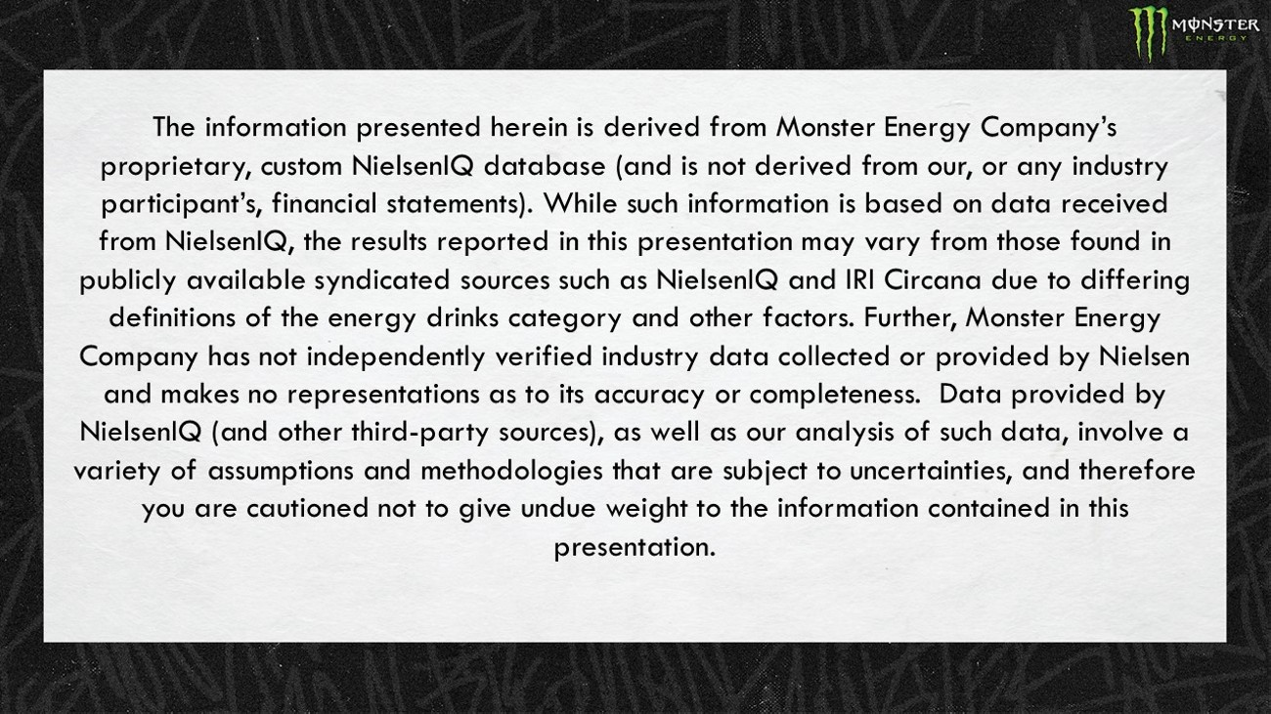
The information presented herein is derived from Monster Energy Company’s proprietary, custom NielsenIQ database (and is not derived from our, or any industry participant’s, financial statements). While such information is based on data received from NielsenIQ , the results reported in this presentation may vary from those found in publicly available syndicated sources such as NielsenIQ and IRI Circana due to differing definitions of the energy drinks category and other factors. Further, Monster Energy Company has not independently verified industry data collected or provided by Nielsen and makes no representations as to its accuracy or completeness. Data provided by NielsenIQ (and other third - party sources), as well as our analysis of such data, involve a variety of assumptions and methodologies that are subject to uncertainties, and therefore you are cautioned not to give undue weight to the information contained in this presentation.

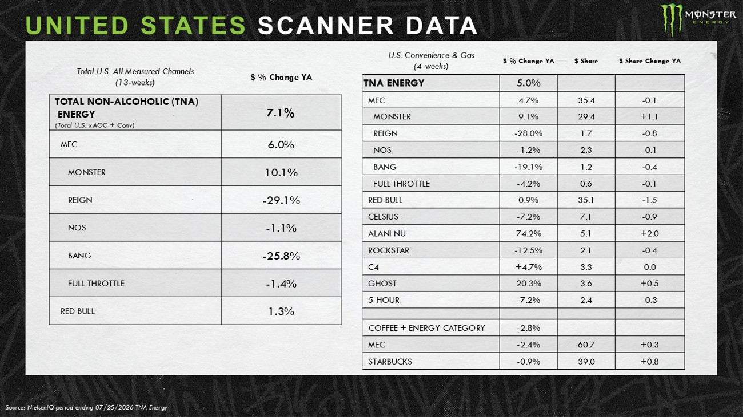
UNITED STATES SCANNER DATA Source: NielsenIQ p eriod ending 07/25/2026 TNA Energy $ % Change YA Total U.S. All Measured Channels (13 - weeks) 7.1% TOTAL NON - ALCOHOLIC (TNA) ENERGY (Total U.S. xAOC + Conv) 6.0% MEC 10.1% MONSTER - 29.1% REIGN - 1.1% NOS - 25.8% BANG - 1.4% FULL THROTTLE 1.3% RED BULL $ Share Change YA $ Share $ % Change YA U.S. Convenience & Gas (4 - weeks) 5.0% TNA ENERGY - 0.1 35.4 4.7% MEC +1.1 29.4 9.1% MONSTER - 0.8 1.7 - 28.0% REIGN - 0.1 2.3 - 1.2% NOS - 0.4 1.2 - 19.1% BANG - 0.1 0.6 - 4.2% FULL THROTTLE - 1.5 35.1 0.9% RED BULL - 0.9 7.1 - 7.2% CELSIUS +2.0 5.1 74.2% ALANI NU - 0.4 2.1 - 12.5% ROCKSTAR 0.0 3.3 +4.7% C4 +0.5 3.6 20.3% GHOST - 0.3 2.4 - 7.2% 5 - HOUR - 2.8% COFFEE + ENERGY CATEGORY +0.3 60.7 - 2.4% MEC +0.8 39.0 - 0.9% STARBUCKS

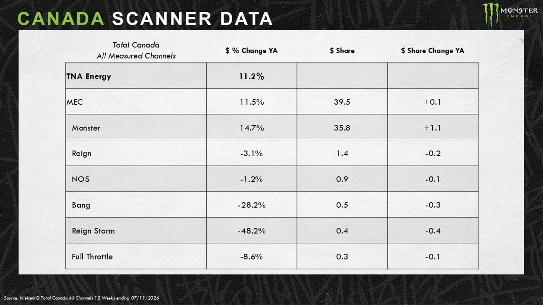
CANADA SCANNER DATA Source: NielsenIQ Total Canada All Channels 12 Weeks ending 07/11/2026 $ Share Change YA $ Share $ % Change YA Total Canada All Measured Channels 11.2% TNA Energy +0.1 39.5 11.5% MEC +1.1 35.8 14.7% Monster - 0.2 1.4 - 3.1% Reign - 0.1 0.9 - 1.2% NOS - 0.3 0.5 - 28.2% Bang - 0.4 0.4 - 48.2% Reign Storm - 0.1 0.3 - 8.6% Full Throttle

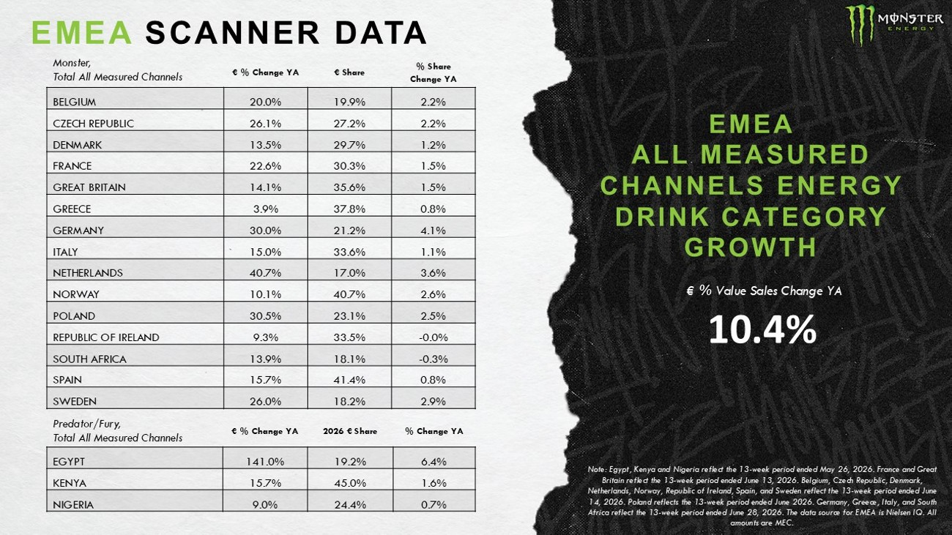
EMEA SCANNER DATA % Share Change YA € Share € % Change YA 2.2% 19.9% 20.0% BELGIUM 2.2% 27.2% 26.1% CZECH REPUBLIC 1.2% 29.7% 13.5% DENMARK 1.5% 30.3% 22.6% FRANCE 1.5% 35.6% 14.1% GREAT BRITAIN 0.8% 37.8% 3.9% GREECE 4.1% 21.2% 30.0% GERMANY 1.1% 33.6% 15.0% ITALY 3.6% 17.0% 40.7% NETHERLANDS 2.6% 40.7% 10.1% NORWAY 2.5% 23.1% 30.5% POLAND - 0.0% 33.5% 9.3% REPUBLIC OF IRELAND - 0.3% 18.1% 13.9% SOUTH AFRICA 0.8% 41.4% 15.7% SPAIN 2.9% 18.2% 26.0% SWEDEN % Change YA 2026 € Share € % Change YA 6.4% 19.2% 141.0% EGYPT 1.6% 45.0% 15.7% KENYA 0.7% 24.4% 9.0% NIGERIA Note: Egypt, Kenya and Nigeria reflect the 13 - week period ended May 26, 2026. France and Great Britain reflect the 13 - week period ended June 13, 2026. Belgium, Czech Republic, Denmark, Netherlands, Norway, Republic of Ireland, Spain, and Sweden reflect the 13 - week period ended June 14, 2026. Poland reflects the 13 - week period ended June 2026. Germany, Greece, Italy, and South Africa reflect the 13 - week period ended June 28, 2026. The data source for EMEA is Nielsen IQ. All amounts are MEC. EMEA ALL MEASURED CHANNELS ENERGY DRINK CATEGORY GROWTH € % Value Sales Change YA Monster, Total All Measured Channels Predator/Fury, Total All Measured Channels 10.4%

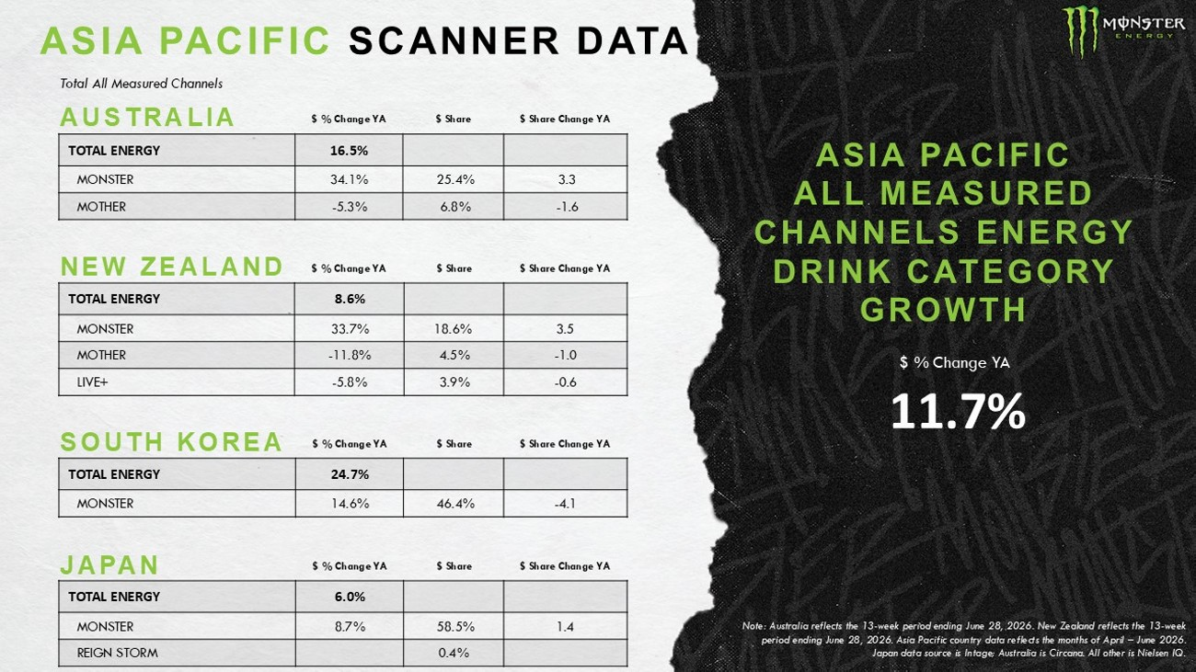
ASIA PACIFIC SCANNER DATA Note: Australia reflects the 13 - week period ending June 28, 2026. New Zealand reflects the 13 - week period ending June 28, 2026. Asia Pacific country data reflects the months of April – June 2026. Japan data source is Intage ; Australia is Circana . All other is Nielsen IQ. 11 .7% $ % Change YA ASIA PACIFIC ALL MEASURED CHANNELS ENERGY DRINK CATEGORY GROWTH $ Share Change YA $ Share $ % Change YA 16.5% TOTAL ENERGY 3.3 25.4% 34.1% MONSTER - 1.6 6.8% - 5.3% MOTHER AUSTRALIA $ Share Change YA $ Share $ % Change YA 8.6% TOTAL ENERGY 3.5 18.6% 33.7% MONSTER - 1.0 4.5% - 11.8% MOTHER - 0.6 3.9% - 5.8% LIVE+ $ Share Change YA $ Share $ % Change YA 6.0% TOTAL ENERGY 1.4 58.5% 8.7% MONSTER 0.4% REIGN STORM $ Share Change YA $ Share $ % Change YA 24.7% TOTAL ENERGY - 4.1 46.4% 14.6% MONSTER NEW ZEALAND SOUTH KOREA JAPAN Total All Measured Channels

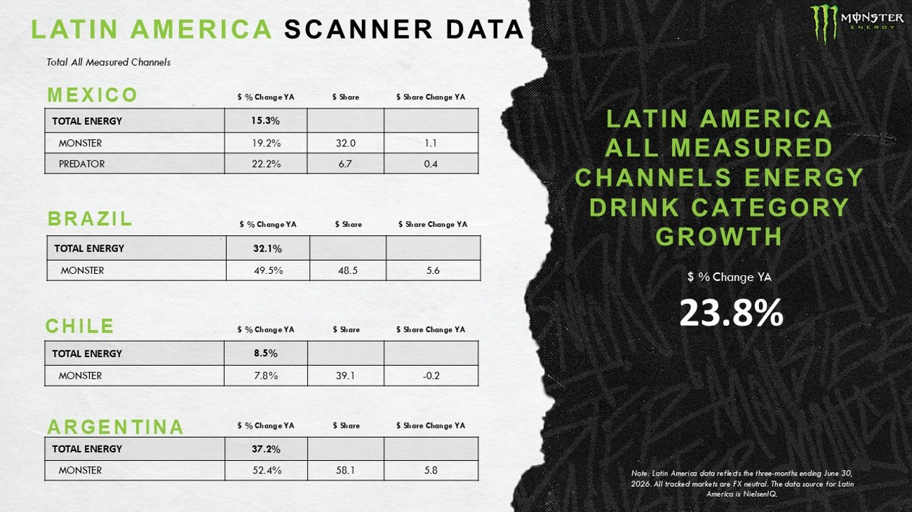
LATIN AMERICA SCANNER DATA 23.8% $ % Change YA LATIN AMERICA ALL MEASURED CHANNELS ENERGY DRINK CATEGORY GROWTH $ Share Change YA $ Share $ % Change YA 15.3% TOTAL ENERGY 1.1 32.0 19.2% MONSTER 0.4 6.7 22.2% PREDATOR MEXICO $ Share Change YA $ Share $ % Change YA 37.2% TOTAL ENERGY 5.8 58.1 52.4% MONSTER $ Share Change YA $ Share $ % Change YA 8.5% TOTAL ENERGY - 0.2 39.1 7.8% MONSTER CHILE ARGENTINA Total All Measured Channels $ Share Change YA $ Share $ % Change YA 32.1% TOTAL ENERGY 5.6 48.5 49.5% MONSTER BRAZIL Note: Latin America data reflects the three - months ending June 30 , 2026. All tracked markets are FX neutral. The data source for Latin America is NielsenIQ .

